Team508: Structural and Thermal Management of an Automotive Battery

Functional Decomposition
Taylor Bethmann
Austin Robertson
Kaleb Sands
Skyler Heft
Mark Hibyan
FAMU-FSU College of Engineering

Functional Decomposition
The purpose of this functional decomposition is to break down the complex battery system into smaller parts. This is done in order to understand what the system has to do and how it can be done. This process starts with the overall battery system being broken down into major components. From here, each of these components are simplified to verbs describing their physical actions and outcomes.

Data Generation
Information for the functions of the battery system was found through research and discussions with advisors on what the system has to do in order to perform effectively. A basic outline was done to get an idea of how the overall system works. From here, the system was broken down into functional components and a flow chart was created. Figure 1 below displays the overall functional decomposition flow chart.

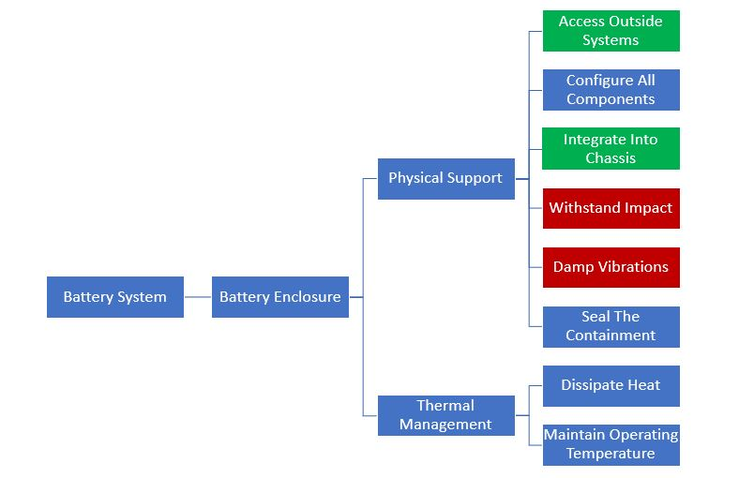
Battery System Functional Decomposition
Figure 1. Total Functional Decomposition flow chart.
The battery system decomposition is placed in order of function priority. Within each level of the system, the functions placed at the top are of highest priority to the project objectives, then decrease as the functions are listed. For example, within the system under the physical support category, being able to access outside systems within the vehicle is the highest priority for being able to physically run and support the battery. On the other hand, sealing the containment is of the lowest priority for the project objectives.
Some of the components within the functional decomposition will have cross subsystem relationships and can be accomplished using a single solution. Thus, these coupled functions are presented in the same colored box to show how these series of functions relates to a sub system of the project. For example, the damping of vibrations and withstanding impact can both be achieved through a structurally secure casing.

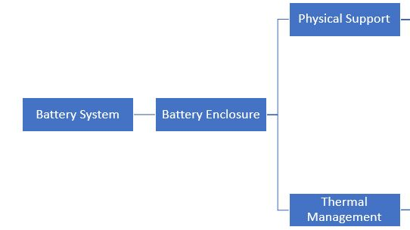
Battery System
Figure 2. Battery System Decomposition flow chart.
In Figure 2 above, the main subsystems can be seen. The broadest component is the battery system, and within this is the battery enclosure. Due to the objectives of this project, the enclosure will be the only battery system component that is being analyzed. The battery enclosure is then broken up into two main functions, the physical support and thermal management. The physical support is in reference to the structure of the housing and how it will perform as a result of various loadings and forces. The thermal management function will account for keeping the battery within the necessary operating temperatures, to ensure safe and efficient performance.

Physical Support
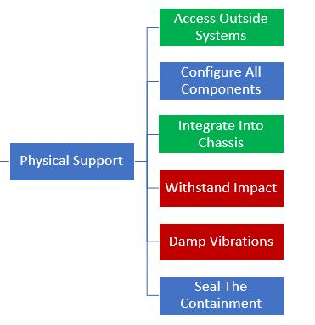

Figure 3. Physical Support Decomposition flow chart.
Figure 3, above, displays the decomposition of one of the main functions, physical support. The physical support must contain and secure all components in the necessary location for operation. These components must be protected from the outside environment and fit within the housing. The support must also allow the battery components to communicate with the other systems within the vehicle, such as the engine. The structure will dampen vibrations due to outside forces and withstand impacts and loadings. Last, the support must integrate into the existing car chassis without interference.

Thermal Management

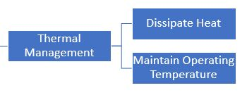

Figure 4. Thermal Management Decomposition flow chart.
In Figure 4 above, the decomposition of the second main function, thermal management, is displayed. The thermal management function will contain components that ensure the battery is operating within a safe temperature range. It will be able to dissipate heat that is generated by the battery, and maintain the necessary operating temperature through additional cooling or heating.

Explanation of Results
As a result of the functional decomposition for the battery system, a better idea of the system and subsystem relationships was established. This will aid in the innovation of the battery components for concept generation and selection. The main objective for this project is to supply a structural and thermal management system for a hybrid vehicle battery, thus the main component under the broadest function of battery system is the battery enclosure. The corresponding functions under this system help describe the actions that need to be accomplished in providing these project objectives. Overall, the broadest and basic functions of the battery system and enclosure were established, guiding further development in the design process.

